**Assignment 10.4**

**Question:** Write a pig script find the average age of male and female persons died in the titanic tragedy

**Code:**

TitanicA = load ‘titanic.txt’ using PigStorage(‘,’) as (PassengerId:int,Survived:int,Pclass:int,Name:chararray,Sex:chararray,Age:int);

b = FILTER TitanicA by $5 is not null;

c = foreach b generate $5;

d = group c all;

e = foreach d generate AVG(c.Age);

dump e;

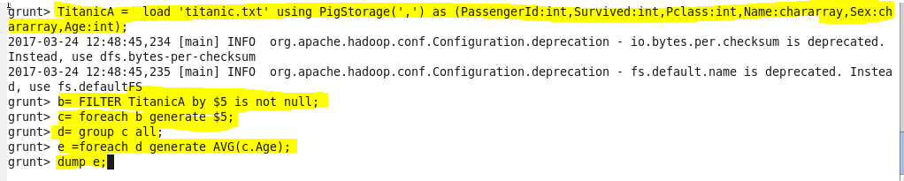

**OUTPUT:**

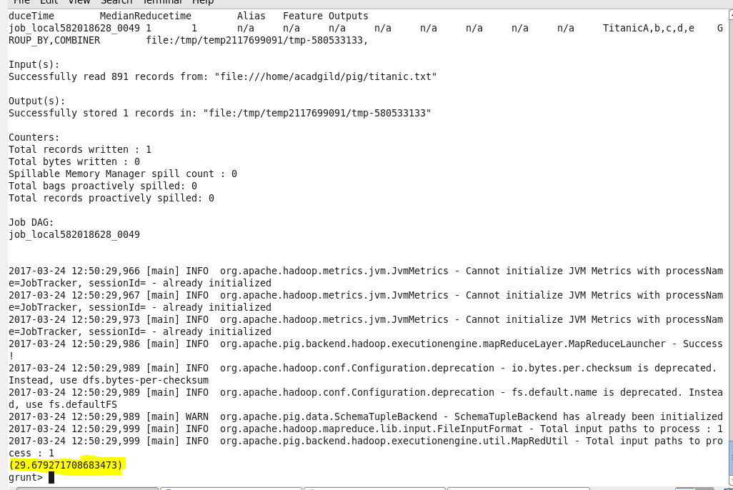

**Question:** Write a pig script to find the number of people died and survived in each class

**Code:**

TitanicA = load ‘titanic.txt’ using PigStorage(‘,’) as (PassengerId:int,Survived:int,Pclass:int,Name:chararray,Sex:chararray,Age:int);

B = group TitanicA by (Survived,Pclass);

C = foreach B generate group,COUNT(TitanicA.PassengerId);

dump C;

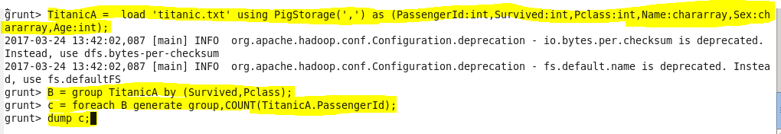

**OUTPUT:**

